# My Implementation

The scene consists of a terrain covered in grass, a castle featuring a (normal map), a fire with smoke and logs (normal map). A shark is in the water using a reflection shader to demonstrate the ability for the shader to compute reflections on complex shapes. The trees are randomly placed with random sizes and rotations to create a natural looking forest. The terrain fades from grass to sand to create natural looking waterholes and shorelines.

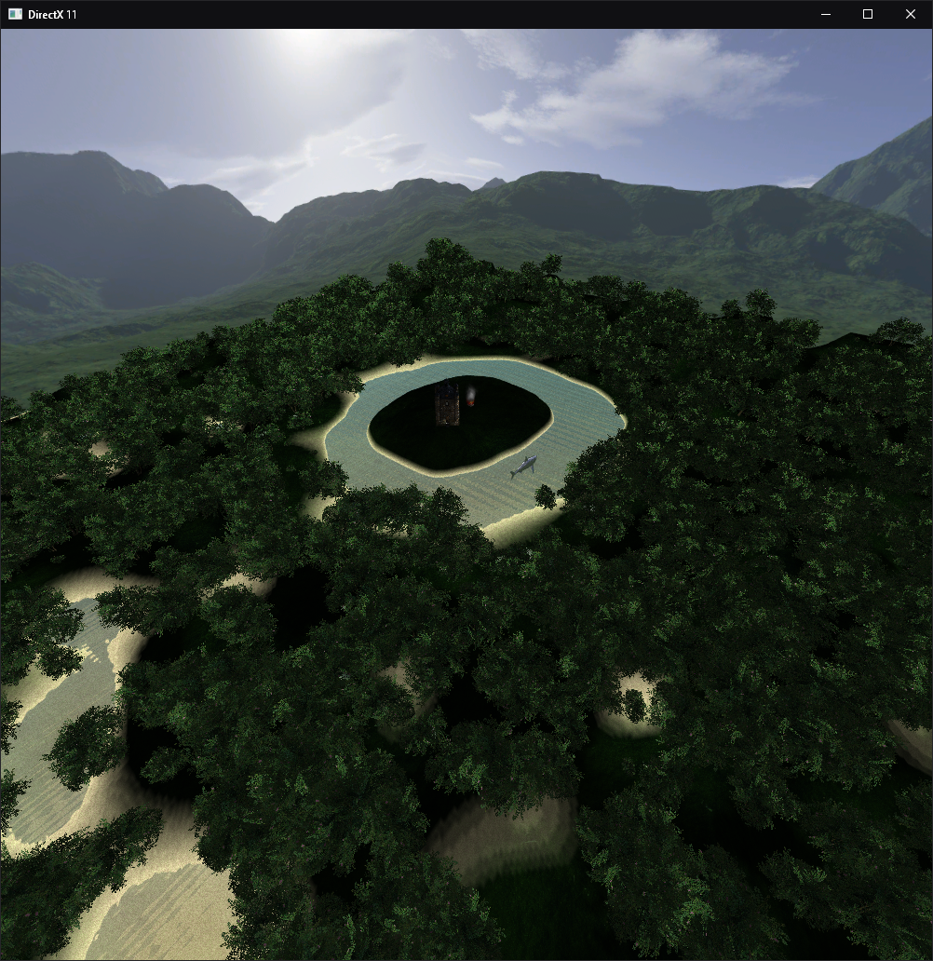

Figure 1: Scene view with flying First Person Camera

# Techniques

## Per Pixel Lighting

Per Pixel Lighting shaders are used within the scene to render the lighting illumination for each pixel on a model. The shader allows for models to be lit based on the light sources position. This creates more realistic lighting as opposed lighting based purely on ambient light.

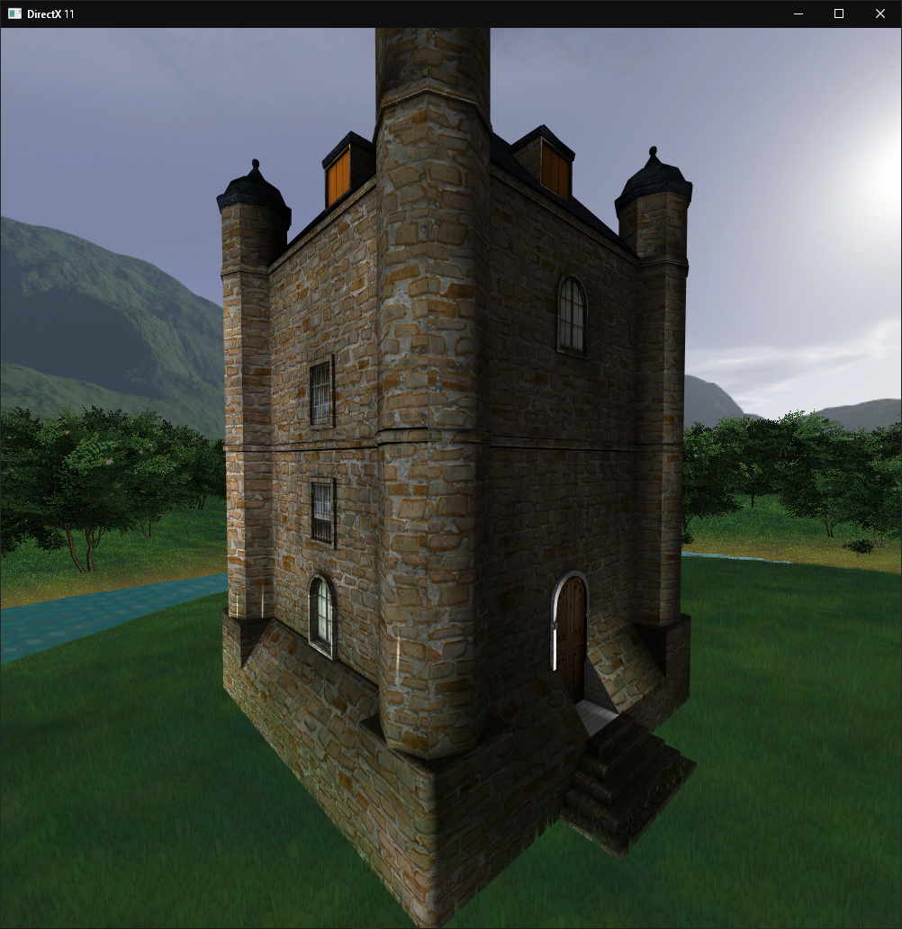

Figure 2: Castle using per pixel lighting.

## Particle Systems

A particle system is used to generate the fire and smoke in the scene. The particle system creates particles and propels them in a defined direction. The particles consist of billboards that are designed to always face the camera. The particles also utilize alpha blending to allow for smooth edges on the smoke.

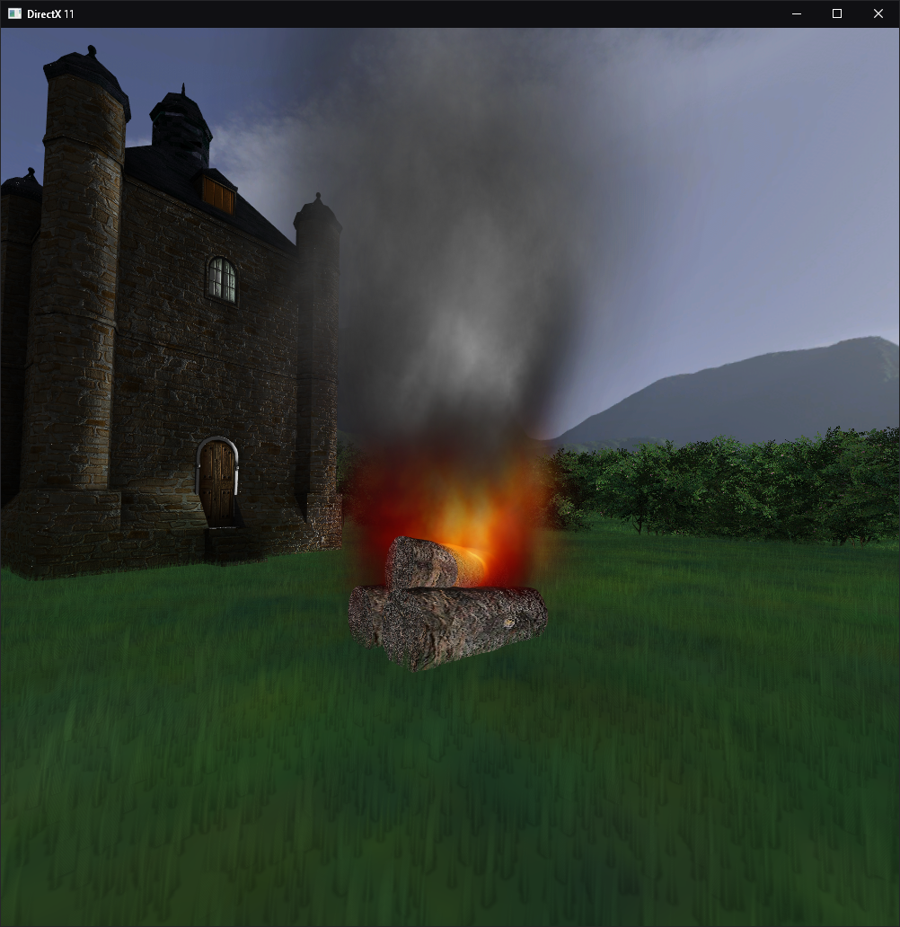

Figure 3: Fire using Particle System

## Tree Generation

The generation done using an array of trees. Positions would be randomly selected as long as they were not within the region of the island which contained the castle.

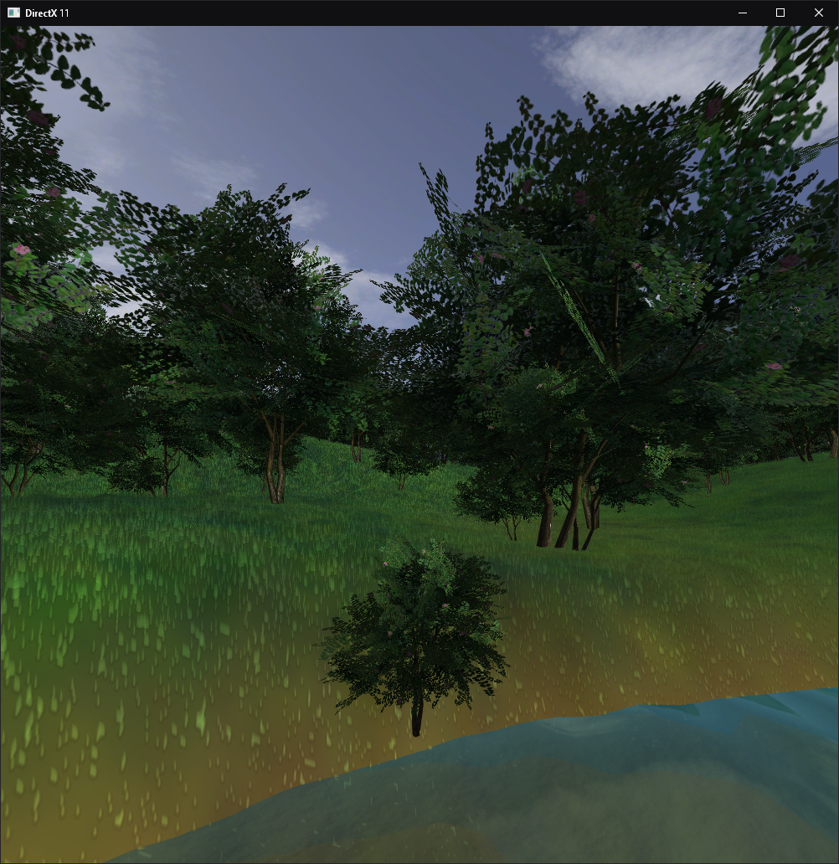

Figure 4: Tree generation showing random positions, sizes and rotations.

## Alpha Blending

Alpha bending allows for textures to contain transparency. This is utilized on the water to provide it with a transparent finish, along with on the trees, smoke/fire and grass.

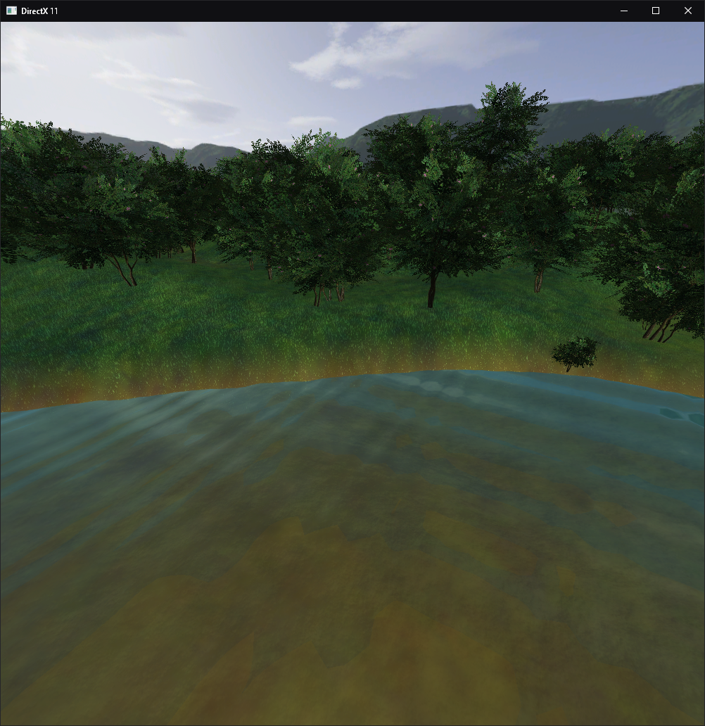

Figure 5: Image of water transparency and tree transparency

## Grass creation

The grass is created using a custom pixel shader and custom vertex shader. The vertex shader handles the grass height along with the shape and movement. The grass colour along with terrain colour is handled within the pixel shader. Within the pixel shader, a lerp is used to change the colour of the terrain depending on it’s height. This creates smooth looking shores along the moat around the castle. The vertex shader also takes the positional height into account and modifies the grass scale in a similar fashion to the lerp, however, it only handles the height between 0 and 1. If the position is below 0.1, it does not render the grass as it is told not to do so in the vertex shader.

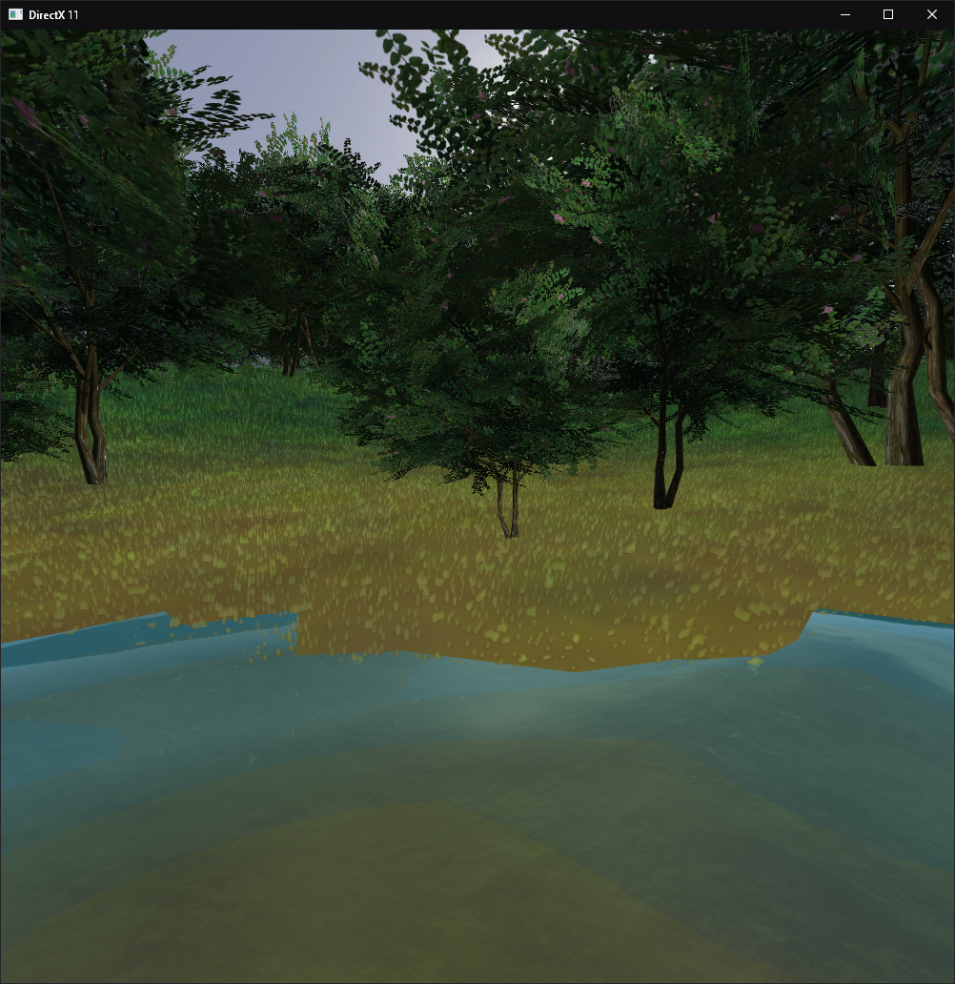

Figure 6: Grass creation with fade away from water.

## Normal Mapping

Normal mapping refers to utilizing a special image to add extra depth to a 2D surface. This provides it with the appearance of a higher quality model that would require more vertices, without the added complexity or processing power impact. This information is passed into the shader and through calculating the bitangent the shading can be altered to provide the aforementioned 3D effect.

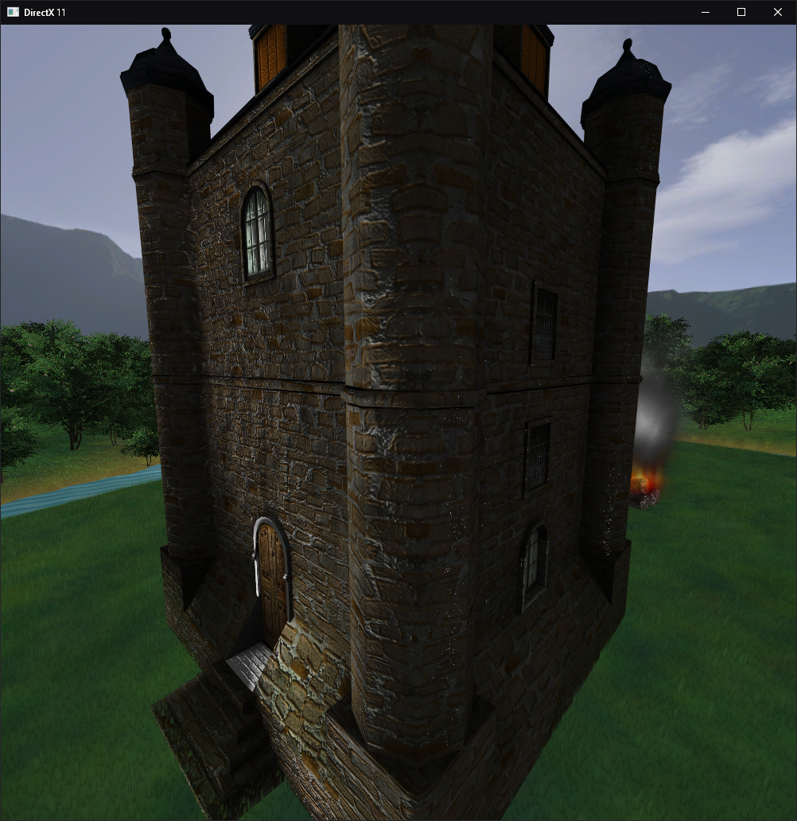

Figure 7: Castle with Normal Map applied

## Environment Effects

An environmental effect featured within the scene is the use of a reflection map on the shark model. Although the shark model is not usually ideal for checking if reflections are working, in this instance they are used in order to demonstrate the ability for the reflections shader to reflect the environment on a complex model.

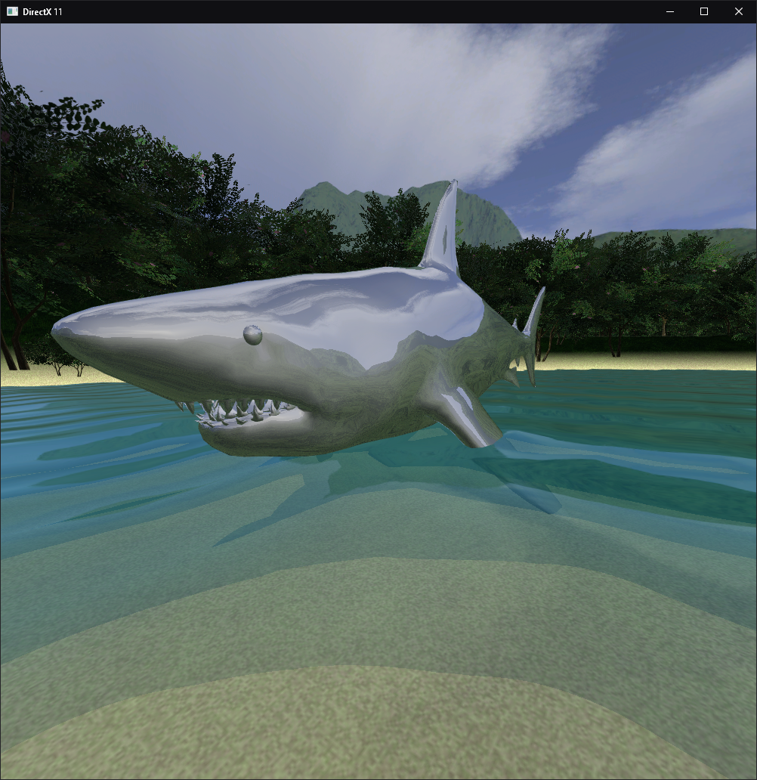

Figure : Reflections of environment shown on shark model

## Camera Controls

The camera was modified to accept first person camera inputs. The camera is a fly camera to allow the user to observe the scene without the limitations of the terrain. The user inputs are WASD for movement along the horizontal plane with SPACE and C being used to traverse the verticality of the height.

## Texture Blending

Texture blending is accomplished on the grass shader by passing in another texture. For the implementation, the second texture is a sand texture. The idea behind texture blending is to switch a texture out with another one at a specific texture coordinate. The scenario does this based on the height of the position to slowly lerp into the colour on the second texture.

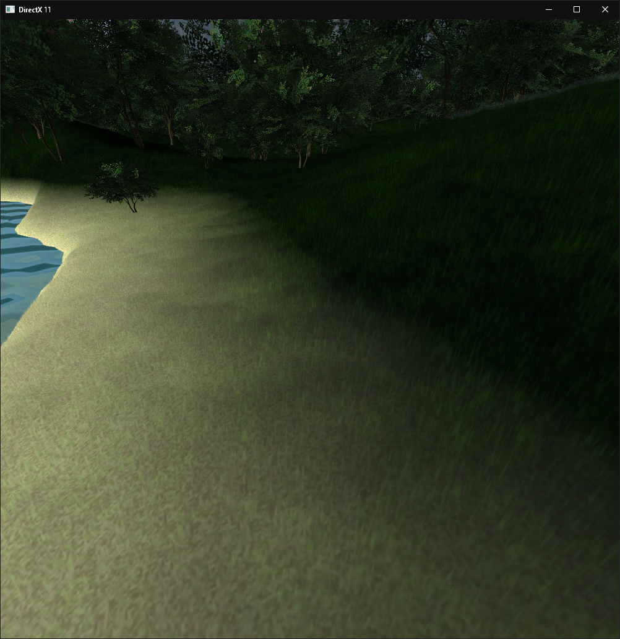

Figure : Texture Blending in Scene

# Testing



Figure : Table showing objects that are enabled per test with FPS, SPF and Memory

For the data collection, each of the object instantiation was halted and the object was not rendered. The data shows that the grass and trees impact performance the most with a 18 FPS increase gained through halting the trees. The memory usage was very close through each run, which is confusing as theoretically the memory should decrease if there are no trees or grass being produced.

The data table represents the data with the FPS and Memory usage using a bar graph on the left vertical axis, and the SPF utilizing the right vertical axis. The data shows that the memory usage is identical or within a margin of error across all tests. The FPS did not increase much with the Water and Normal Maps disabled, along with the SPF’s being within a very small margin. This means that the effects did not impact performance much.

# Future Improvements

## Light Attenuation

This feature would allow for lights to have drop-off. This would make point lights more realistic as they do in modern videogames.

## Animations

Optimally, a dragon could be added to the scene with working animations. This would provide the scene with more life, as opposed to it being filled with static objects. Along with this, the reflection shark could be animated to swim around

## Object Glow

Adding glow to other objects would have allowed for the creation of a sun as a light source. This would have added realism to the scene.

## Water shader improvements

Currently, the water texture has a terrible appearance around the shorelines. This could be improved through the addition of a shoreline texture to disrupt the perfect looking water surface. This occurs in the real world and makes edges softer.

## Multiple light support

Multiple lights being added to the scene would be a nice addition along with attenuation. This would allow the scene to have more depth and lightsources such as lamps could be added. The scene could have added variety to locations, with lights holding the potential to completely change the aesthetic of an area.

## Shadows

Shadows add a lot of realism to the scene as they greatly effect lighting. The performance impact would be moderate. This would be done by deciphering which vertices are behind an object and on the opposite side of the light source. It would then shade those pixels to a darker colour (grey or black).

## Variety of Tree Models

To create a more realistic forest, a variety of tree models could be selected in order to provide more variety. Variety is already attempted through the alteration of size, however, the changing of tree models would provide more variety in shape and colour.

## Falling Particles (Rain/Snow)

Particles could be utilized to add more of an atmosphere to the scenario. The scene could be given a dark theme with rain falling to represent a miserable evening, as opposed to a clear sky with no particle effects falling from the sky. This would be done by either adding world space objects that fall, or camera space. Camera space would mean that the water particles could not interact with the ground, and extra mathematics would need to be conducted to prevent raining inside of buildings, or under trees.

## Terrain Tessellation

Terrain Tessellation could be utilized to create effects such as settled snow. Often, tessellation is used in video games to also add detail to models, such as brick walls. This is an alternative to a normal map (or can be used in addition with) as it displaces the vertices as opposed to simply adding shadows on the model to provide a 3D submit.

## Fog

To create an eerie atmosphere in the map, fog could be added. This could be applied to hide objects in the distance and fade anything beyond a distance away from the camera.

## Mist

Mist could be created using the particles to create a light mist above the water. Again, this could be added in order to add to the atmosphere of the entire scene.